- Log into https://servicecenter.bncservices.com/sc/index.php
- The main screen shows current backorders and daily virtual bookstore activity.
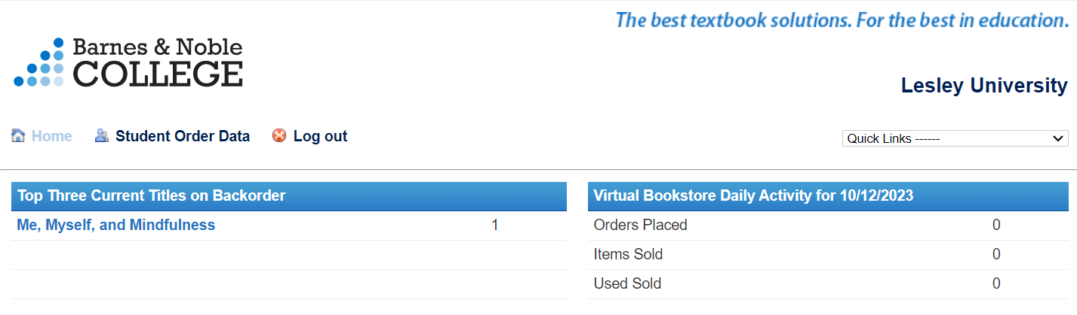
- Click on “Student Order Data”
  - You have several different search options, in this example, I will use “Search by Order Number” – input search criteria and hit “submit”
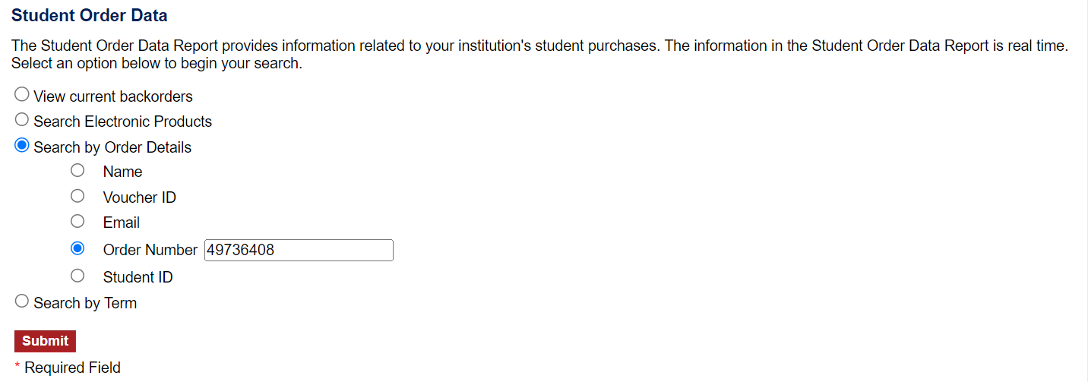
- You may then see the order summary, along with shipping information.
  - Note: This will not show the method of payment (student credit card vs SFA voucher/advance vs scholarship)
