How to Add/Edit Vouchers in Service Center
- Log into Service Center using your credentials
  - https://servicecenter.bncservices.com/sc/index.php
  - Username:
  - For security purposes, I will send your password in a separate email.
- From the “Quick Links” drop-down menu in the upper-right corner, select “Student Financial Aid/Voucher Order”
  - 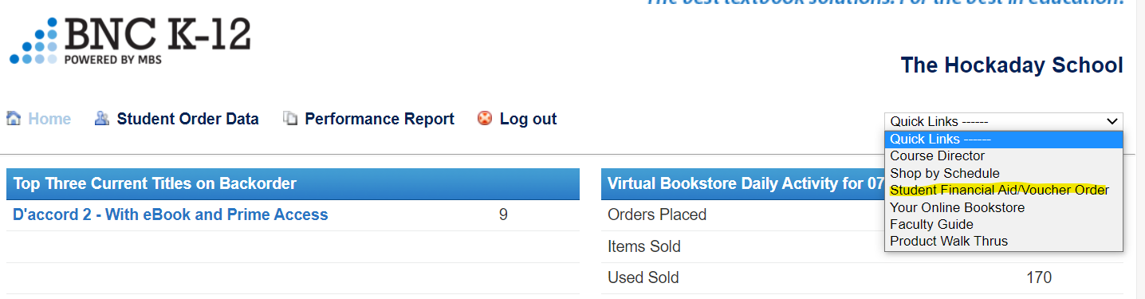

- From here, you may add a new voucher (allocate SFA), view/edit existing vouchers, as well as place/view voucher orders.

Allocate SFA
- Click “Allocate SFA” in the top left box.
  - 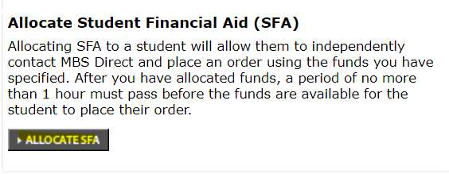

- Click “Add Allocation to Batch”
  - 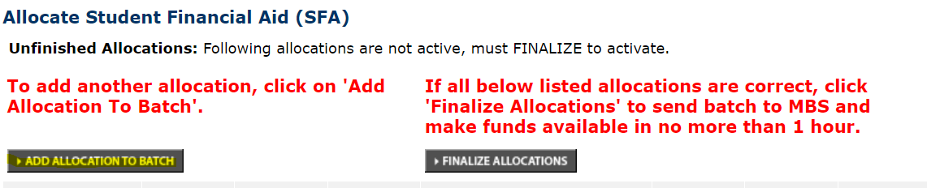

- Enter the student’s information in the appropriate field and click “Add Allocation to Batch”
  - 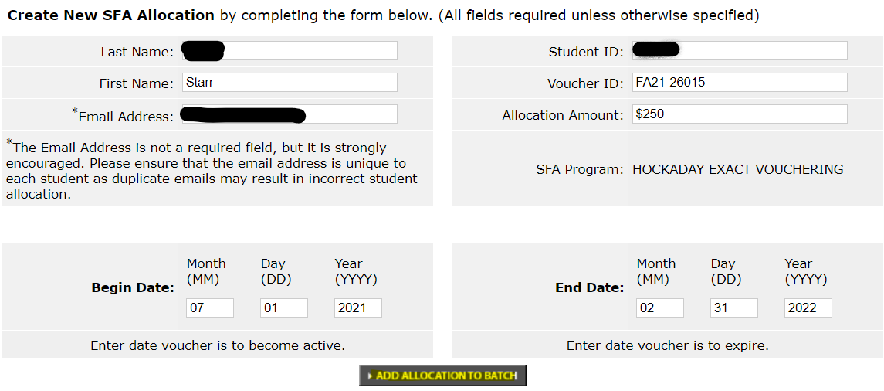

  - Please note: some field are marked out due to the sensitive information they contain. You will need to enter that information to proceed.
- Click “Finalize Allocations”
  - 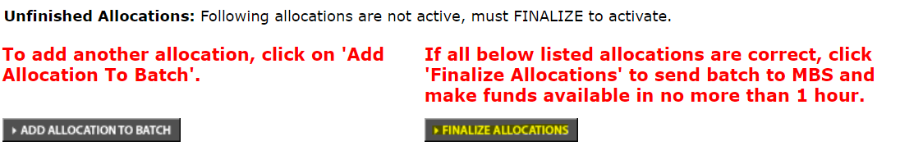

  - Please note: It may take up to an hour for these to be active.

Edit SFA
- Click “View SFA Allocations” in the top right box.
  - 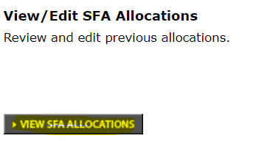

- To find the voucher you’d like to view/edit, search by student name, email, or student ID.
  - 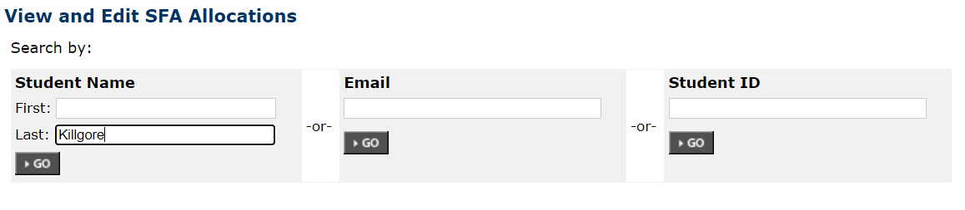

- Click Edit
  - 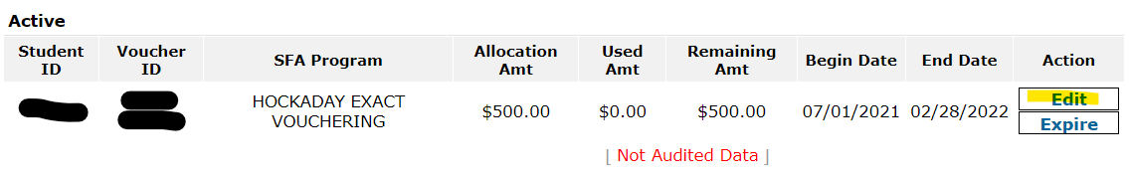

- From here, you can change the available voucher amount or the expiration date.
  - 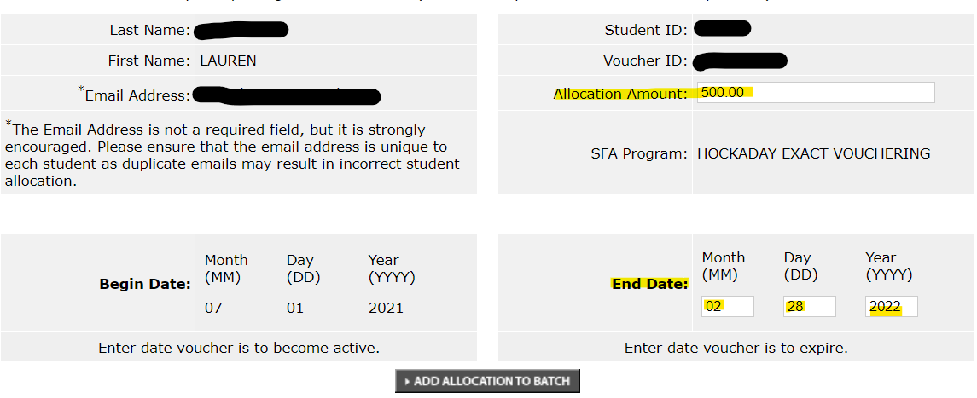

- Click “Add Allocation to Batch” & “Finalize Allocations”
  - Please note: It may take up to an hour for these changes to reflect.

